Program 11
Create a HTML registration form and validate the form using JavaScript code. The validation should include the following:
1. Name validation/Mandatory field validation
2. password validation
3. Email validation
4. Mobile number validation

eventHandling3.html:
<html>
<head>
<title>PROGRAM 11</title>
<style>
body {
text-align: center;
background-color: #f7f8fa;
margin-top: 40px;
}

h1 {
font-size: 32px;
color: #2c3e50;
margin-bottom: 20px;
}

h2 {
font-size: 22px;
color: #34495e;
margin-bottom: 20px;
}

form {
display: inline-block;
text-align: left;
background-color: white;
padding: 25px 40px;
border-radius: 8px;
box-shadow: 0 0 10px rgba(0, 0, 0, 0.1);
width: 320px;
}

label {
font-weight: bold;
}

input[type="text"], input[type="password"] {
width: 100%;
padding: 8px;
margin: 6px 0 12px 0;
border: 1px solid #ccc;
border-radius: 4px;
box-sizing: border-box;
}

input[type="submit"] {
background-color: #4CAF50;
color: white;
border: none;
padding: 10px 20px;
font-size: 16px;
border-radius: 5px;
cursor: pointer;
}

p {
color: red;
font-size: 14px;
margin-top: -10px;
margin-bottom: 10px;
}
</style>
</head>
<body>
<h1>FORM VALIDATION</h1>
<form name="regForm" method="post" action="" onsubmit="return formValidate()">
<h2>Registration Form</h2>

<label>Name :</label>
<input type="text" id="fname" name="fname">
<p id="p1"></p>

<label>Email :</label>
<input type="text" id="email" name="email"><br>
<p id="p2"></p>

<label>Mobile Number :</label>
<input type="text" id="phno" name="phno"><br>
<p id="p3"></p>
<label>Password :</label>
<input type="text" id="password" name="password"><br>
<p id="p4"></p>
<input type="submit" value="Submit" name="submit">
</form>
<script>
function formValidate(){
let name = document.regForm.fname.value;
let email = document.forms["regForm"]["email"].value;
let phno = document.getElementById("phno").value;
let password = document.getElementById("password").value;
atpos = email.indexOf('@');
dotpos = email.lastIndexOf('.');
//name field check
if (name == "" || name == null){
document.getElementById("p1").innerHTML = "Name field cannot be empty!";
return false;
}
//email field check
else if(email == "" || email == "null"){
document.getElementById("p2").innerHTML = "Email field cannot be empty!";
return false;
}
//Email format check
else if(atpos < 1 || dotpos < atpos+2 || dotpos+2 >= email.length){
document.getElementById("p2").innerHTML = "must at username@domain.com format!";
return false;
}
//Mobine number and legth check
else if(isNaN(phno) || phno.length != 10){
document.getElementById("p3").innerHTML = "Must be number and 10 digit!";
return false;
}
//Password length check
else if(password.length<6){
document.getElementById("p4").innerHTML = "Password must be at least 6 characters long!";
return false;
}
else{
alert("Successfully Registered ");
}
}
</script>
</body>
</html>

OUTPUT:
Form: 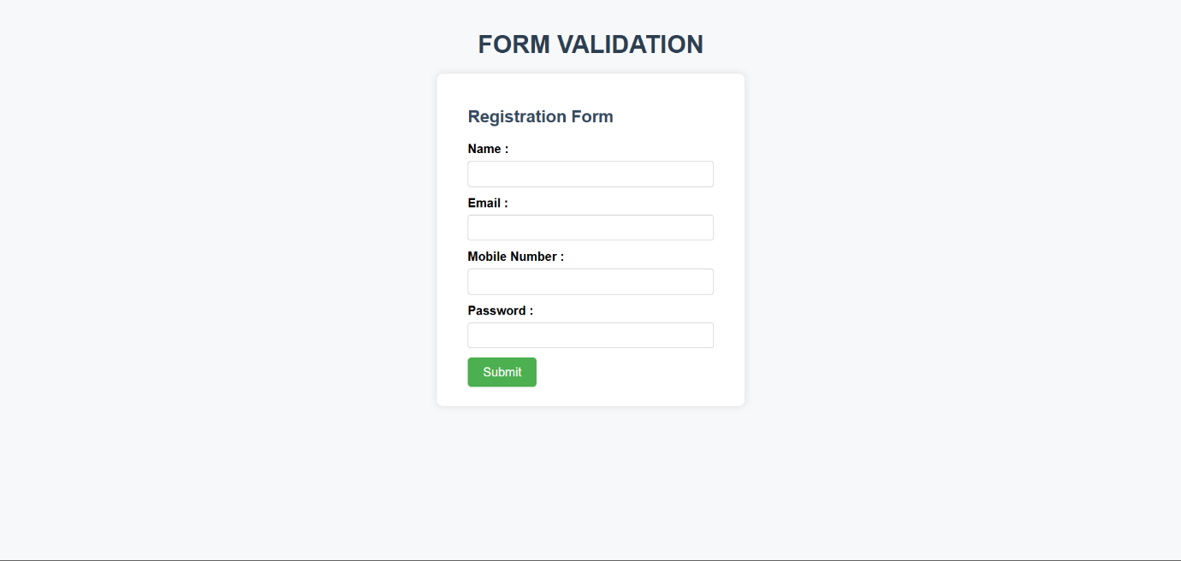

Name filed cannot be empty: 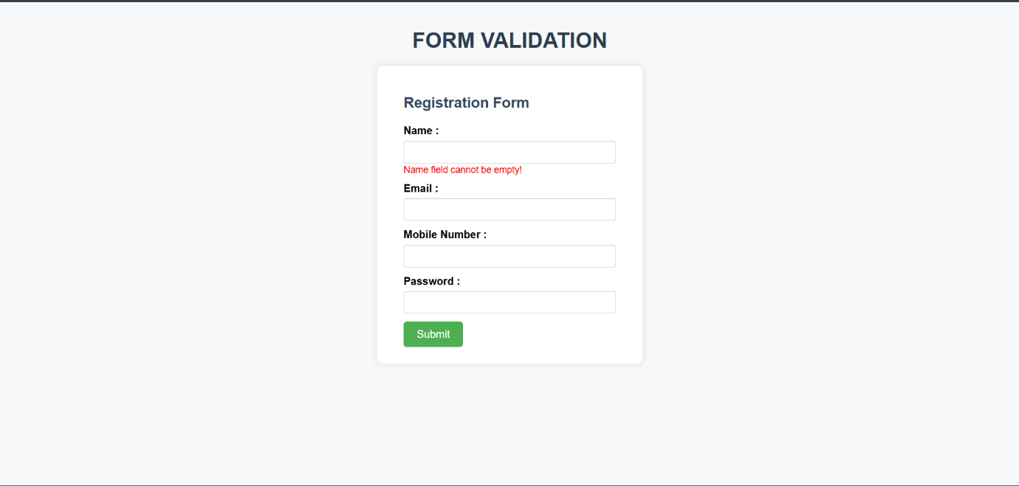

Email must be correct format:
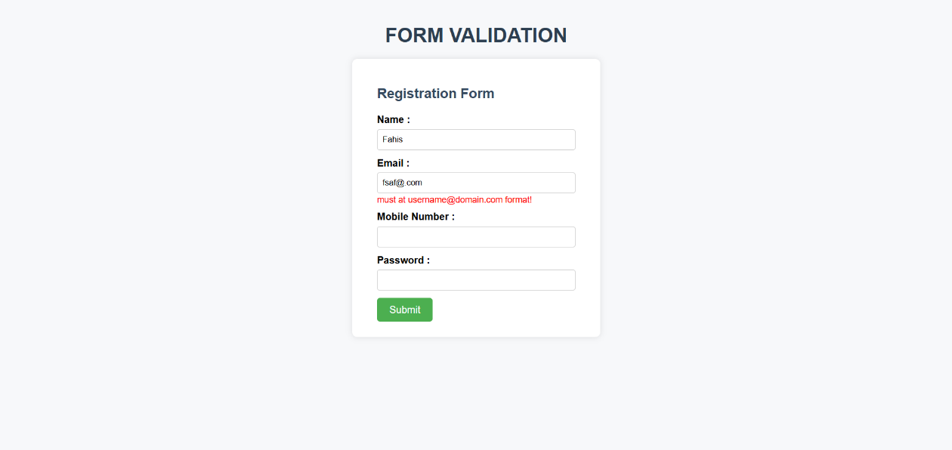
Mobile number must 10 digits:
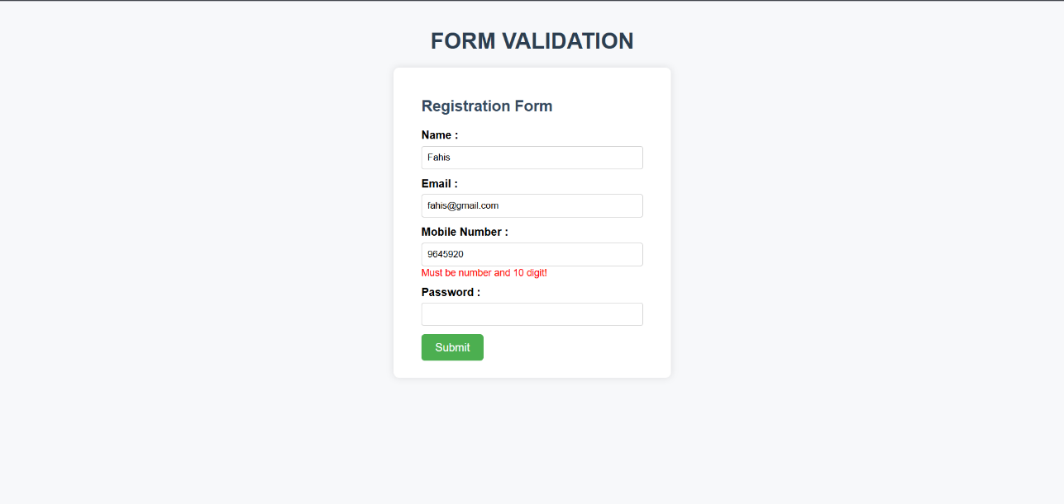
Password cannot less than 8 characters:
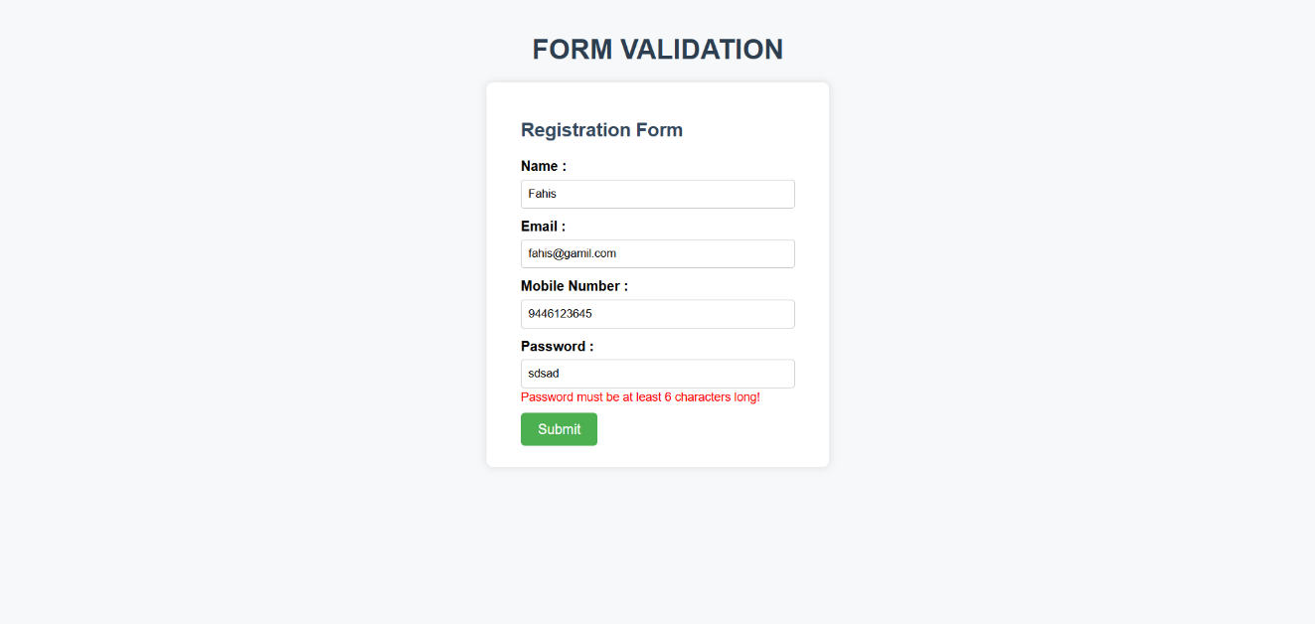
Successful Registration :
